2 Billion Miles: A Refugee's Journey

- Write down the origin point of your refugee’s country and each stop he/she made along the way to his/her destination. You do not have to fill out all lines, only as far as your person traveled.
  - Origin Country/City ___________________
  - Country City Traveled to ______________
  - Country City Traveled to _______________
  - Country City Traveled to _______________
  - Country City Traveled to _______________
  - Country City Traveled to _______________
  - Country City Traveled to _______________
  - Country City Traveled to _______________
  - Country City Traveled to _______________
  - Country City Traveled to _______________
  - Country City Traveled to _______________
  - Country City Traveled to _______________

- What type of international migration did your refuge take; forced or voluntary? Explain your reasoning: ____________________________________________________________________________________________________________________________________________________________________________________________________________________________________________________________________________________________________________________________________________________________________________________________________________________________________

- Was there any internal migration that took place. If so list the times when your person had any interregional migration or intraregional migration: __________________________________________________________________________________________________________________________________________________________________________________________________________________________________________________________________________________________________________________________________________________________________________________________________________________________________________________________________________________________________________

- What were some of the push factors that caused the refugee to leave his/her home:_________________________________________________________________________________________________________________________________________________________________________________________________________________________________________________________________________________________________________________________________________________________
- What were some of the pull factors that brought the person into places throughout the journey and to their final destination? __________________________________________________________________________________________________________________________________________________________________________________________________________________________________________________________________________________________________________________________________________________________________________________________________________________________________________________________________________________________________________

- What were some of the obstacles the refuge faced along the way? Do you think immigrants in other parts of the world face similar challenges, why or why not? ________________________________________________________________________________________________________________________________________________________________________________________________________________________________________________________________________________________________________________________________________________________________________________________________________________________________________________________________________________________________________________________________________________________________________________
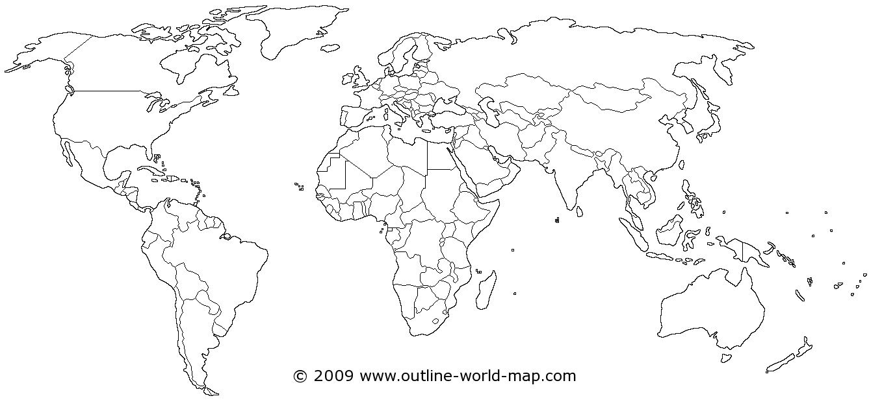
- Label the places that your refuge traveled to and draw arrows from place to place that demonstrates the journey.
- Total Number of Miles Traveled: _________________________________________

