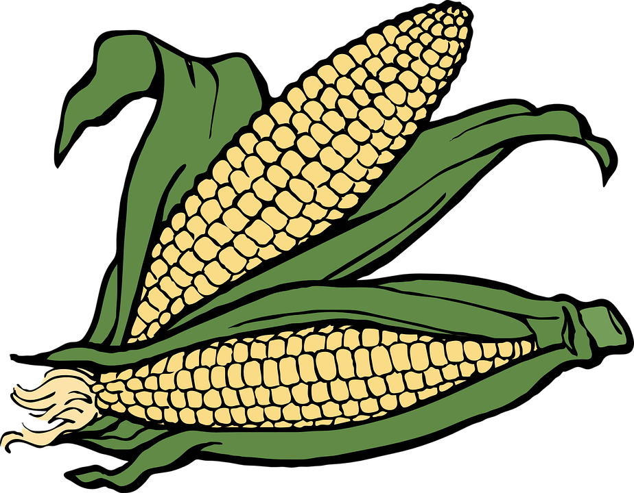
Agriculture Speed Dating

You will each be assigned a type of agriculture you must fill out your dating profile (below) based on your type of agriculture. We will then speed date to determine which type of agriculture will be your best match.

Types of Agriculture:
Pastoral Nomadism
Shifting Cultivation
Transhumance
Intensive Subsistence- Wet Rice
Intensive Subsistence- Crops other than rice dominant
Plantation Farming
Mixed Crop and Livestock
Dairy Farming
Commercial Gardening/ Fruit Farming
Livestock Ranching
Subsistence Agriculture
Commercial Agriculture
Grain Farming
Mediterranean Agriculture

