Key Issue 1: Why Do Services Cluster Downtown?
Pages 460-465

***Always keep your key term packet out whenever you take notes from Rubenstein. As the terms come up in the text, think through the significance of the term.
- Define the term CBD in one word.
Downtown
- List four characteristics of a typical CBD.
a-compact with < 1% of urban land area
b-large % of public, business and consumer services

Using your knowledge of services from chapter 12, define each term and give an example of a typical downtown shop with that characteristic.
- High Threshold-stores would cluster near the 100% corner where it had the highest accessibility for customers. Examples would be Large Department stores

- High Range- often specialists with customers from all over who visit them infrequently. They have also moved with department store to suburban areas. Jewelry or clothing stores

- Why are these shops decreasing in the CBD? Stores have difficulty in attracting their old customers. Retail on the ground floor, and office buildings on the top.

- Another type of shop in the CBD are those which provide services to downtown workers. Give three examples. Office supplies, computers, shoe repair, clothing, rapid photocopying, dry cleaning, Apple, Macy's, Dillard's

- Why are these shops increasing? Downtown office workers has increased and the demand for these services has also increased. Most business people work in the CBD, so they are likely to shop there during breaks.

- High rents___ and ___land shortage_____ discourage
_industrial _______and _______residential__________ in the CBD.

- What is happening to the old manufacturing districts in American CBDs? Cities are taking those areas and changing them into waterfronts. They are using them as major tourist attractions. New parks, museums, parking lots, docks, walkways, large convention centers and trade shows. Hotels, restaurants, boutiques and entertainment centers.

- Regarding residential uses – identify a factor pushing them out of the CBD and another that is pulling them elsewhere.

Pushing… | Pulling…
High rents, dirt, crime, congestion, poverty | Larger homes, private yards, modern schools

- Describe how the intense land use of CBDs has created expansion of the CBD “above” and “below” in order to maximize the small space of the downtown? CBDs can't leave downtown area so they expand underground and above ground.

- What is a food desert? An area in a country where healthy food is difficult to obtain. Common in low-income areas.

- How is the underground utilized in cities? Below is where cities include garages, loading docks, pipes for water/sewer, telephone, broadband service, overhead poles, pedestrian passages, shops and other amenities.

- How is “land use” distributed within a typical skyscraper? CBD’s have increased the above land use by building upwards, through skyscrapers, allowing the vertical geography. Herein, you will find stores, offices, apartments/condos, businesses.

- What is the only major U.S. city without skyscrapers? Washington DC

Key Issue 2: Where Are People Distributed Within Urban Areas?
Pages 466-475

- Read the following section of this key issue and for each of the three models, annotate the diagrams below and do the following:
- Identify the model by name
- Name the geographer(2) who developed the model
- Define the model
- Identify and label key parts of the model
- Bullet important characteristics and/or features of the model

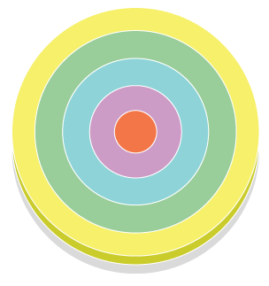 | - Concentric Zone Model  - Sociologist E. W. Burgess  - City grows outward from the central area in a serious of concentric rings like the growth rings of a tree. The precise growth of the rings varies from city to city.  - Orange-CBD; Purple-zone in transition (industry, poorer-quality housing, immigrants, rooming houses, larger houses subdivided into small dwelling units); blue-working class homes(modest older houses, stale working-class families); green-zone of better residences-newer more spacious houses for middle class homes, commuting in, cheaper land; yellow-commuters zone-small villages, dormitory towns for commuters. People are able to afford their housing.  - See d  City develops in sectors that branch out from CBD

- Sector model
- Homer Hoyt, land economist
- City develops in sectors not in rings
- 1. CBD 2. Transportation & Industry 3. Low class residential 4. Middle class residential 5. High class residential
- Certain areas are more attractive for various activities, originally because of an environmental factor or even by mere chance. Once a district with high-class housing is established, the most expensive new housing is built on the outer edge of that district, farther out from the center (see purple).
Developed in sectors in wedges.
Better housing found in a corridor from downtown to city edge Industry & retail develop along transport lines
City develops in sectors that branch out from CBD

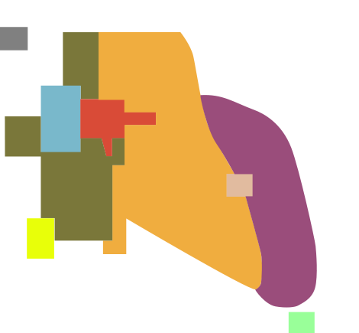 | - Multiple Nuclei Model  - Geographers C.D. Harris and E. L. Ullman  - Red-CBD; yellow-medium class residential; white-outlying business district; purple-high class residential; light green-residential suburb; yellow-heavy manufacturing; dark green-low class residential; light blue-wholesale, light manufacturing  - Red-CBD; yellow-medium class residential; white-outlying business district; purple-high class residential; light green-residential suburb; yellow-heavy manufacturing; dark green-low class residential; light blue-wholesale, light manufacturing  1. CBD 2. Transportation & Industry 3. Low class residential 4. Middle class residential 5. High class residential  Better housing found in a corridor from downtown to city edge Industry & retail develop along transport lines  City develops in sectors that branch out from CBD
2. What are census tracts? Urban areas with approximately 5000 residents and correspond, to neighborhood boundaries.
3. What three types of data are reported by the U.S. Census Bureau regarding the population of each census tract? # of nonwhites, median income of all families, % of adults who finished high school
4. What is social area analysis? Comparing people of similar living standards, ethnic background and lifestyle within an urban area.
- What two things can we deduce by combining all three models rather than considering them independently? -People tend to reside in contain locations depending on particular personal characteristics.
-People prefer to live near others who have similar characteristics.

- What are the advantages of living in the inner-ring near the city center? Proximity to shops, restaurants, cafes & cultural facilities

- List three points about the conditions of European suburbs, where the poor live.
Long commutes on public transportation; poorer shops and schools; crime, violence and drug dealing

- List five ways that a European CBD differs from a North American CBD.
Not as commercial
Low rise structures
Minimal noter vehicles
Many residents
Rents are higher due to less land

- Explain the Latin American City Model in the chart below as you did for the models above.
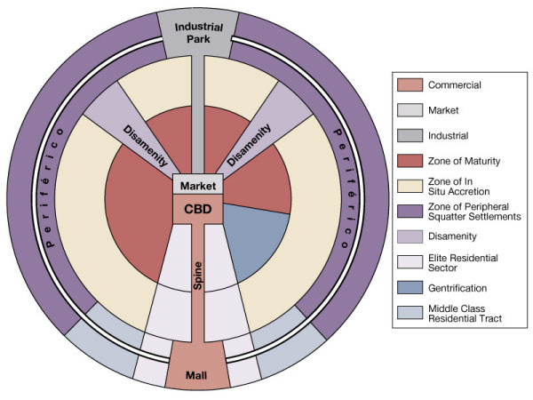
- Describe the elite spine sector developed in Latin American cities.
Elite residential sector with offices, shops, & amenities for wealthy people; water & electricity readily available.
- What are the causes of squatter settlement? Population increase and migration from rural areas for jobs; housing shortage for large number of urban immigrants.

- Define squatter settlements. City where water is carried from a central well/from a truck; City in an LDC unable to house the rapidly growing no. of poor people

14. Describe services and amenities in a typical squatter settlement. Latrines designated by settle meant leaders; water carried from a well; electricity stolen by running wire to power line.

- Make a simple flowchart which depicts stages in the development of a squatter settlement.

Camp on land or sleep in street Severe weather – camp in markets or warehouses |  | Families build shelter  with cardboard,  wooded boxes, crushed  cans |  | Build on a roof & partition space into rooms for more permanent settlement

- Cities in Africa, Asia and Latin America resemble European cities in their structure. This is not a coincidence because….

- Draw and label a sketch of a “pre-colonial city”

4 Concentric rings labeled as follows
Ring 1 (inner circle) – High status businesses related to religious practices located near mosque
Ring 2 – Secular businesses such as leather works, tailors, jewelers
Ring 3 – Food products
Ring 4 (outer circle) – Blacksmiths, basket makers, potter

- Colonial cities often contained a new “European sector” to the side of the pre-colonial city. Contrast their various elements in the table below.

“Old Quarters” – pre-colonial city | “European district” – colonial addition
-Narrow winding streets  -little open space  -cramped residences | -greed street plan  -church or central plaza  -walls around houses  -wider streets  -lower population density

Key Issue 3: Why Are Urban Areas Expanding?
Pages 476-489
- List the elements of an urban area according to the peripheral model.
Consists of an inner city surrounded by a large suburban residential and business areas that live together by a bell way or ring road.

- Complete the table below regarding peripheral areas.

Problems They Lack | Problems They Have
The severe physical, social, and economic problems of inner city neighborhoods. | Sprawl and segregation that characterize many suburbs.

- Define city: An urban settlement that has been legally incorporated into an independent, self-governing unit

- What are the three basic characteristics of a city? Locally elected officials, ability to raise taxes, and responsibility for essential services.

- Define urbanized area: urban area with at least 50,000 inhabitants.

- What is the functional area of a city? Metropolitan statistical area

- What does the MSA include?
-Urbanized area with a population of at least 50,00
-Country that city is located in
-Adjacent countries with high population density and large % residents wording in CBD.

- What is a Megalopolis? Greed word that means “great city”

- What is the Megalopolis from Boston to D.C. called? Boswash Corridor
- Define council of government: Cooperative agency
- What is annexation? The process of legally adding land area to a city

- What is required before an area can be annexed by a city?
Majority of residents in affected area vote in favor of annexation.

- In the past, why did peripheral areas desire annexation?
Because the city offered better services.

- What has changed? Resident prefer to organize their own services rather than pay city taxes for them.

- Describe the density gradient of an urban area. Number of houses per unit of land diminishes as the distance from the center of the city increases.

- In what two ways has the density gradient changed in recent years?
1. fewer people live in the center
2. fewer differences in densities in Urban Areas

- Define sprawl: Progressive spread of development over a landscape.

- What is meant by the statement: the “periphery of U.S. cities looks like Swiss cheese”?
Pockets of development and gapes of open space land.
- What has prevented the peripheries of European cities from looking like Swiss cheese?
Building new houses is restricted/greenbelt around cities.
- What is smart growth?
Legislation and regulations to limit suburb sprawl and preserved farmland.

- Describe how “smart growth” laws have been designed in the following states?

Maryland | Oregon & Tennessee
Discourages the state from funding new highways and other projects that would extend suburban sprawl and destroy farmland. | Defined growth boundaries with in which new development must occur

- In what two ways are suburban areas segregated?
1. Segregated social casses.
2. Segregated land uses.

- What is a zoning ordinance? Legal restrictions on land uses that determine what types of buildings are allowed to be in certain areas. Prevents the mixing of land uses within the same district.

- What is the strongest criticism of U.S. suburbs? Low-income folks & minorities are unable to live in suburbs due to cost and unfriendliness of residents.

- Define edge city:
A large node of office and retail activities on the edge of an urban area.

- Bullet important information regarding:
Suburbanization of Consumer Services
Suburbanization of business services and factories

- Identify two ways in which the U.S. Government has encouraged the use of motor vehicles by its citizens.
- pay 90% of cost of limited access highway
-Supports police

- List four ways demand for congested roads is being reduced
- congestion charges
- tolls
- permits
- bons
- What is rush hour and how much of a city’s traffic does it account for?
Peak hour with the heaviest traffic
40% of all traffic

- Briefly describe what has happened (or is happening) to each of the following modes of public transportation in U.S. cities.

Trolleys | 30,000 miles of track in early 1900’s to just a few hundred remaining
Buses | - Declined from 11 billion riders in 1940’s to 6 billion in the 21st century
Rapid Transit (subway & fixed rail line) | New subway lines have been created to attract new passengers; modernization of subway lines; riders have increased by 1 billion in 10 years

- List four ways in which public transportation is better than an automobile.
-Moving large numbers of people
-Cheaper
-Less pollution
-More energy efficient

- Briefly explain ways cars may become more energy efficient in the future.

Key Issue 4: Why Do Cities Face Challenges?
Pages 490-495

- Complete this statement regarding the basic problems of the inner city:

“Inner cities in the United States contain concentrations of low income people with a variety of physical, ___social____, and __economic____ problems very different from those faced by _suburban_____ residents.”
- What is the major problem faced by inner-city residents?
Poor condition of housing

- Describe the inner-city process known as filtering.
Large home that are subdivided into smaller dwellings for low-income families

- What is the ultimate result of this process?
Building will deteriorate & become uninhabitable; even the poorest people won’t rent & the property is left abandoned
- What is redlining and its result?
When banks draw lines on a map where they will refuse to loan money & it’s difficult for families to borrow money to fix up houses
- Complete the chart below regarding public housing.

Public Housing
Who builds & maintains it? | Federal Government
Percentage in the U.S. | 1%
Reasons high-rise public housing is unsatisfactory | Elevators broken  Juveniles terrorize residents  Drug use and high crime
How are recent public housing projects different? | Support for renovation of older public housing & voucher program helps pay rent in private housing

- Define gentrification:
When middle class people move into deteriorated inner-city neighborhoods & renovate the housing

- What three groups are attracted to gentrified areas and why?
Middle class families wanting larger homes at a cheaper price - Middle class people who want to live closer to work downtown - Single people seeking proximity to cultural facilities & aren’t concerned with quality of schools

- Why has gentrification been criticized?
Middle class are getting subsidies at expense of low income people who are forced to move out of gentrified neighborhoods

Inner-City Social Issues
- Complete the statement regarding the population in the inner-city:

“Inner-city residents frequently are referred to as a permanent __underclass____ because they are ____trapped__ in an unending ____cycle__ of economic and social ____problems____.” List and briefly describe four specific social problems of the underclass.

- What financial crisis does the high proportion of low-income residents in the inner city create?
Growing gap between costs of needed services & availability of funds to pay for them

- Explain the two choices a city has in order to solve this problem.
-Reduce services: close libraries, don’t replace school equipment, cut busing
- Raise tax revenues: Provide breaks to downtown businesses that will hire minimum wage workers & eventually pay more in taxes

- What two things are happening to homeowners who have been unable to repay their subprime loans?
Foreclosure & mortgages exceed the value of the homes

- Give three examples of some thriving CBDs that have been revived and explain why they’re doing well
Navy Pier- converted to shops and attractions
South Street Seaport- old fish market with retailing and recreational activities
Harbor Place- tourist attractions, hotels, and cultural facilities

