**Columbian Exchange**

**Part A**

|  |  |
| --- | --- |
| **Favorite Foods** | **Ingredients** |
|  |  |
|  |  |
|  |  |

**Part B**

**The Columbian Exchange:**

**Part C Look at the following list and add the items to the table below in the column where you think they belong:** corn, wheat, many spices, lettuce, cotton, squash, smallpox, horses, plague, chickens, cows, sheep, rabbit, buffalo (bison), potatoes, flu, chicken pox, tomatoes, turkeys, carrots, syphilis, sugarcane, cocoa, bananas.

|  |  |
| --- | --- |
| **Old World** | **New World** |
| **Plants:**  **Animals:**    **Diseases:** | **Plants:**  **Animals:**  **Diseases:** |

**Part D: A Global Exchange**



**Part E**

Look at the PowerPoint map, find the ingredients of your favorite foods and place them in their proper “world”.

**New World Old World**

From Europe, Africa, and Asia to the Americas

to Europe, Africa, and Asia

From the Americas to Europe, Africa, and Asia

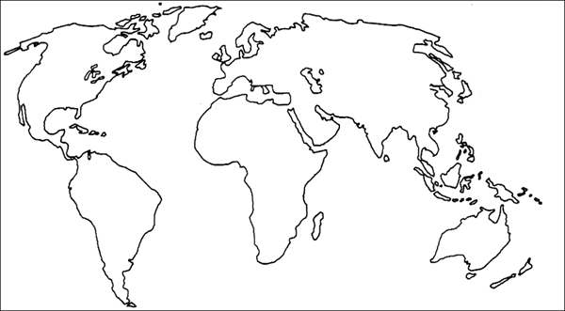

|  |  |
| --- | --- |
| **New World** | **Old World** |
|  |  |

**Part F**

Would any of the food on your favorites list exist today without the Columbian Exchange? Which ones? If not, are any close?