**Population . 13–17%**

A. Geographical analysis of population

1. Density, distribution, and scale

2. Implications of various densities and distributions

3. Patterns of composition: age, sex, race, and ethnicity

4. Population and natural hazards: past, present, and future

B. Population growth and decline over time and space

1. Historical trends and projections for the future

2. Theories of population growth, including the Demographic Transition Model

3. Patterns of fertility, mortality, and health

4. Regional variations of demographic transitions

5. Effects of population policies

C. Population movement

1. Migration selectivity

2. Major voluntary and involuntary migrations at different scales

3. Theories of migration, including push and pull factors, human capital, and life course

4. International migration and refugees

5. Socioeconomic consequences of migration

**Content:**

**Population Profiles (Pyramids)**



Explain these are different

**Circle and name the regions with the highest population.**



**Draw and Label the Demographic Transition Model (CBR, CDR, NG)** Explain what is happening at each stage.

|  |  |  |  |  |
| --- | --- | --- | --- | --- |
| **Phase 1** | **Phase 2** | **Phase 3** | **Phase 4** | **Phase 5** |
|  |  |  |  |  |

**Migration:**

**Ravenstein Laws: Who migrates and why?**

**Lee: Why people migrate (push and pull forces).**

**Most likely to Migrate:**

**Intranationally ______________________________________________________________________________**

**Internationally_______________________________________________________________________________**

**Types of Migration:**

**Forced:**

**Refugee and characteristics**

**Step and chain:**

**Major migrations:**

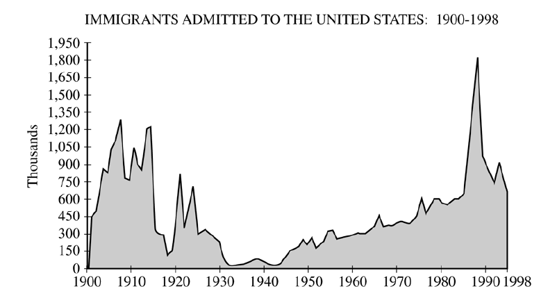

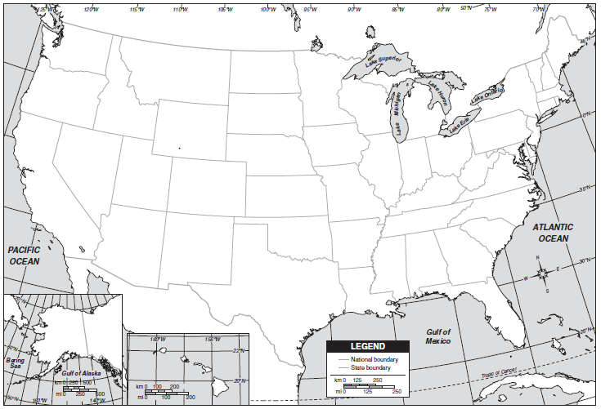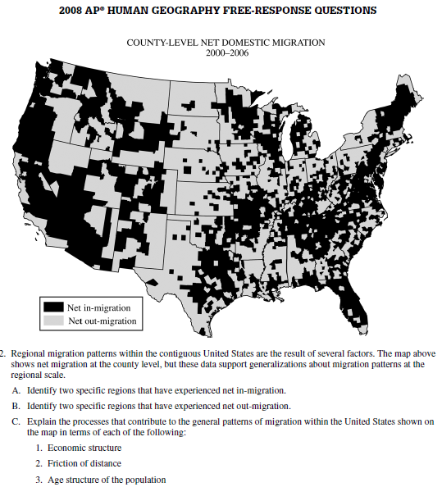

**Be able to identify:**

Dixie

Eastern Sea Board

Gulf Coast

Midwest

New England

Ohio Valley

Plains States

Southwest

Southeast

Northwest

**Belts:**

Corn Belt

Cotton Belt

Frost Belt

Rust Belt

Sun Belt

West Coast

**Be able to give examples of:**

**How migrants change the place they leave?**

**How do migrants change the sites of their new homes?**

**How do governments impact migration?**

**-internal**

**-external**

**-immigration**

**Selective**

**Quotas**

**Refugees:**

**Characteristics**

**Preferred Destinations**

**Regions of Dislocation**

**Major European colonizers:**

**Impacts of colonization:**

**Positive Negative**