Pros for Dropping the Atomic Bombs
- It caused the surrender of Japan.
The Allies were preparing an invasion of Japan in 1945. The plan was to invade Kyushu in October 1945, followed by Honshu five months later. However, there was much thought about whether Japan would not surrender unless something of a very destructive nature were to be demonstrated
- It was preferable to invasion.
With the planned invasion of Japan, millions of American and British lives would surely have been lost. To avoid that, the bombing was seen as a better alternative. In a speech to the British House of Commons on August 1945, Winston Churchill, leader of the Opposition, had this to say: “There are voices which assert that the bomb should never have been used at all. I cannot associate myself with such idead. […] I am surprised that very worthy people – but people who in most cases had no intention of proceeding to the Japanese front themselves – should adopt the position that rather than throw this bomb, we should have sacrificed a million American and a quarter of a million British lives.”
- It saved civilian lives.
Supporters of the bombing believed that waiting for the Japanese to surrender would have cost many civilian lives. Millions of laborers working in harsh conditions under a forced mobilization were liberated when the war ended. Lee Kuan Yew, former Prime Minister of Singapore, said: “But they showed a meanness and viciousness towards their enemies equal to the Huns’. Genghis Khan and his hordes could not have been more merciless. I have no doubts about whether the two atom bombs dropped on Hiroshima and Nagasaki were necessary. Without them, hundreds of thousands of civilians in Malaya and Singapore, and millions in Japan itself, would have perished.”
- It ended total war.
The Japanese government promulgated a National Mobilization Law and waged total war. They ordered a lot of civilians, including women and children, to work in factories and military offices to fight against any invading force.
Those who support the bombing cite the strategic significance of the targets. Hiroshima was the headquarters of the Fifth Division of the 2nd General Army and they commanded the defense of southern Japan. It was also a communication center, an assembly for troops, a storage point and also had several military factories. Nagasaki was a hub of wide-ranging industrial activity that included production of ordnance, ships, military equipment and other war materials.
- Rape of Nanking: 300,000 Chinese are killed by the Japanese Army.
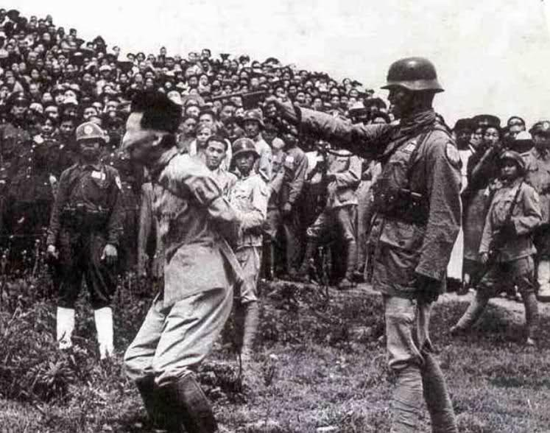

Cons for Dropping the Atomic Bombs
- It was fundamentally immoral.
A report by the Federal Council of Churches called Atomic Warfare and the Christian Faith released in 1946 said: “As American Christians, we are deeply penitent for the irresponsible use already made of the atomic bomb. We are agreed that, whatever be one’s judgment of the war in principle, the surprise bombings of Hiroshima and Nagasaki are morally indefensible.”
- It was considered a war crime.
Critics of the bombings characterized them as war crimes, crimes against humanity and state terrorism. Among those who criticized the events of August 1945 include Albert Einstein, Eugene Wigner and Leo Szilard. The trio incited the first bomb research in 1939 when they sent President Franklin D. Roosevelt a letter stating that Germany might develop atomic bombs and that the US should start their own nuclear program. As a result, the Manhattan Project was created. Einstein later regretted the later as it was used against civilian populations.
- It was unnecessary.
A 1946 United States Strategic Bomb Survey in Japan concluded that the bombing was unnecessary to win the war. The report stated that “[…] it seems clear that, even without the atomic bombing attacks, air supremacy over Japan could have exerted sufficient pressure to bring about unconditional surrender and obviate the need for invasion.”
The report also continued, “[…] Japan would have surrendered even if the atomic bombs had not been dropped, even if Russia had not entered the war, and even if no invasion had been planned or contemplated.”
Also, the bombing of Nagasaki three days after Hiroshima was deemed unnecessary. For one, people haven’t yet fully comprehended the devastation and the second bombing was just “gratuitous at best and genocidal at worst.”
- It was considered state terrorism.
According to historical accounts, the decision to use the atomic bombs was to provoke a surrender by the Japanese through use of an awe-inspiring power. Michael Walzer then commented that it was an act of “war terrorism: the effort to kill civilians in such large numbers that their government is forced to surrender.”
- Effects of the Atomic bomb on Japan: not only is the city destroyed but people were scarred for generations from radiation.
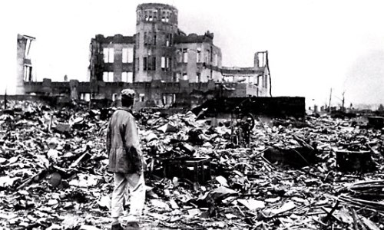

Dropping of the Atomic Bombs: Should we have done it?
By August 1945, the Second World War had been going on for six years. The war on the European front had been concluded with Nazi Germany having signed its instrument of surrender. On the Pacific front, however, war was still dragging on with Japan refusing to quit. The Allies demanded their unconditional surrender in the Potsdam Declaration on July 26, 1945 with the threat of “prompt and utter destruction.”
The Allied Manhattan Project successfully detonated an atomic device. That same team then produced two atomic weapons based on two alternate designs. Japan had already suffered from a destructive firebombing campaign carried out by Allied forces. But on August 1945, the country was to suffer the worst bombing in history: two atomic bombs were dropped on the Japanese cities of Hiroshima and Nagasaki. As a result, around 129,000 people were killed. The bombing remains the only use of nuclear weapons for warfare in history.
Questions: With a Partner read the pros and cons of dropping the Atomic Bomb. Then answer the following questions.
Pros
- After reading the list of Pros for dropping the atomic bombs, write them down in the order of what you think is the most effective argument.

- Summarize your top three choices in one sentence each.

- Explain in 1 to 2 sentences why you chose your top choice. Why is it the biggest reason we did the right thing in dropping the atomic bombs?

Cons
- After reading the list of Cons for dropping the atomic bombs, write them down in the order of what you think is the most effective argument.

- Summarize your top three choices in one sentence each.

- Explain in 1 to 2 sentences why you chose your top choice. Why is it the biggest reason we should not have dropped the atomic bombs?

