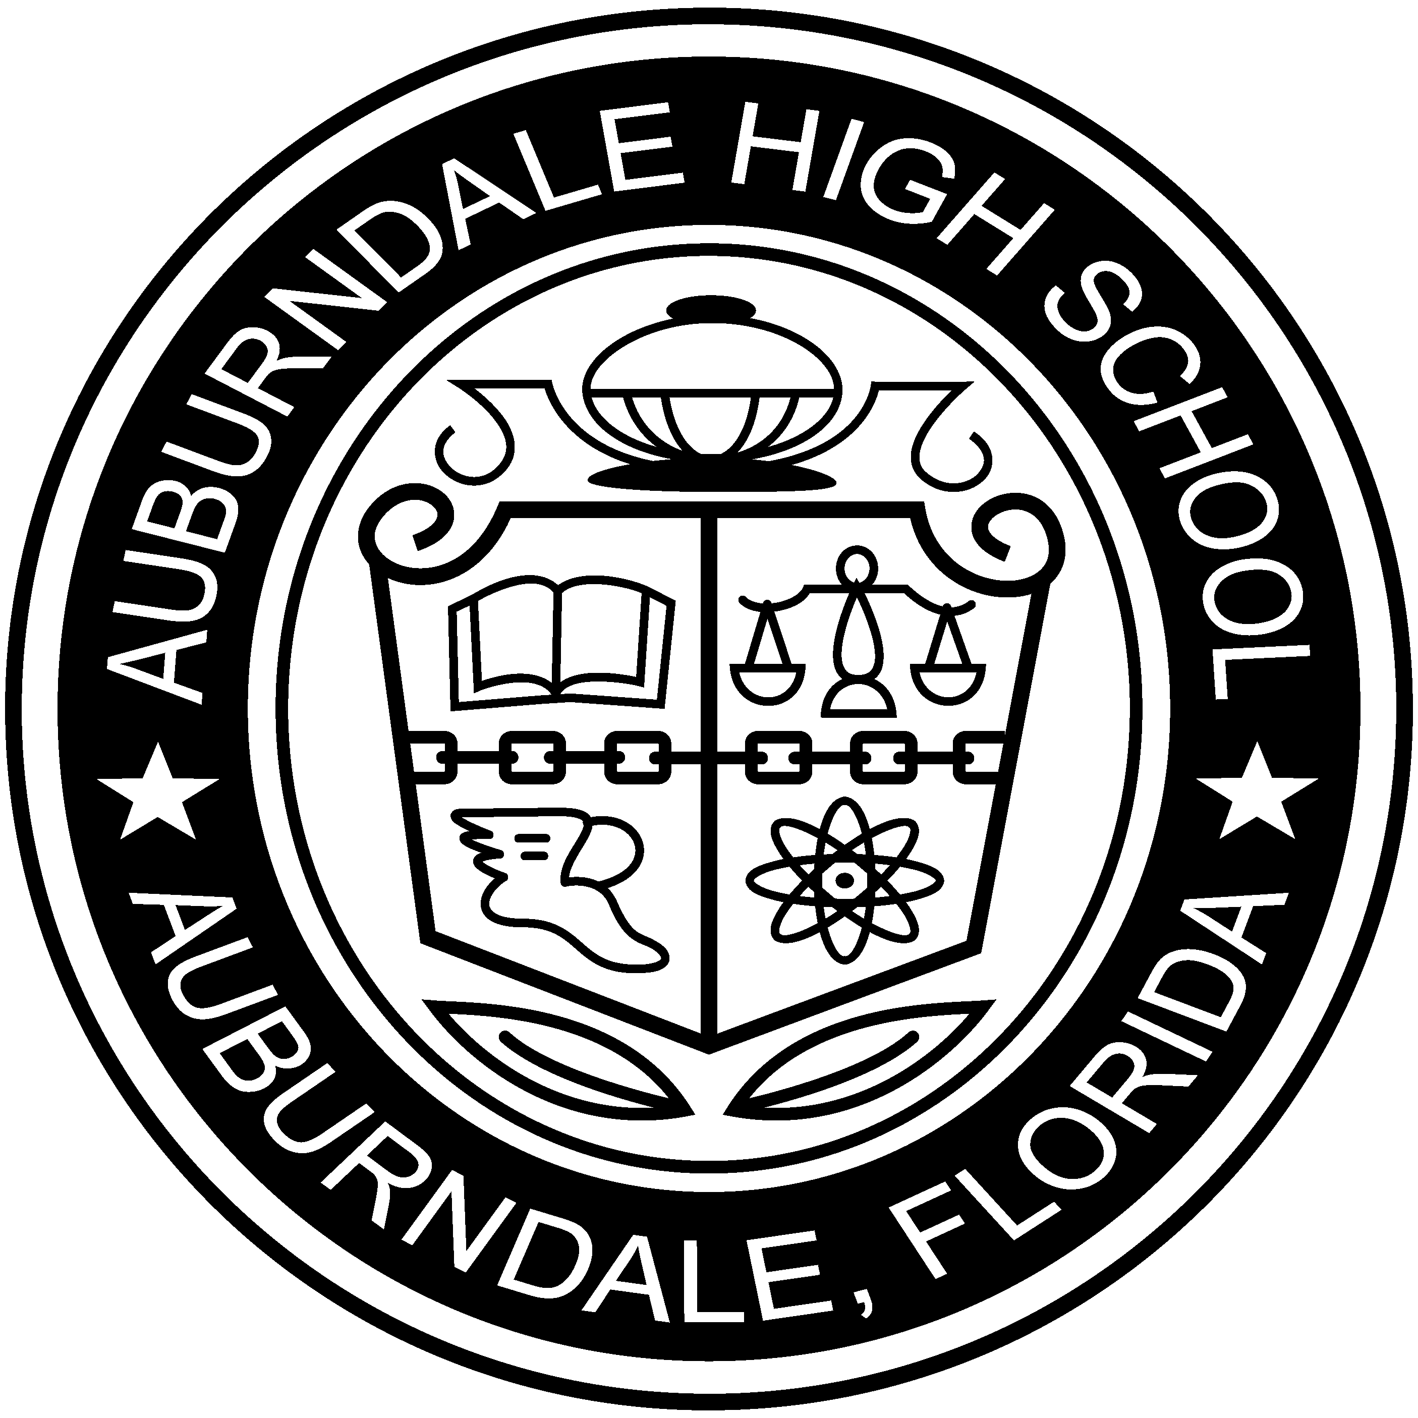 | SYLLABUS: World History & World History Honors  21093200  Terms 1 and 2/ 2018-2019  Room 723  Website: http://urhistteach.weebly.com/

CONTACT INFORMATION: David Thorpe, Instructor, david.thorpe@polk-fl.net
- I am available for assistance and make-up work, tests, etc, before and after school on most days between 2:00-2:30 p.m. I am at AHS by 6:00 AM Monday through Friday. It is recommended that you let me know when you will be stopping by, due to the numerous meetings that take place throughout the school year.
- My E-mail address is: david.thorpe@polk-fl.net
PREREQUISITES TO THE COURSE:
World History Honors and World History is a tenth-grade course, required for graduation. The level of Honors is based on the recommendation of the ninth-grade English teacher. Students have, presumably, completed a course in Geography during their Middle school years. World History Honors will have more rigor and depth added to the course.
GENERAL LEARNING GOALS OR OBJECTIVES:
Through a variety of learning techniques, i.e., lecture, instructional video, note taking, writing, reading, the student will gain a better understanding of the present by in-depth study of the past. (S)He will also be able to form educated opinions of the future based on the occurrences of both past and present.
COURSE MATERIALS: Students need to come to class every day prepared to work.
- Paper, pen (1 red preferably), tissues and pencils are essential.
- Colored pencils for any map work that may take place throughout the term.
- A 2-3 inch binder, tab dividers and loose leaf paper are required. You may substitute a binder for a 5 OR 7 subject spiral notebook and a folder to keep handouts in order.
- (Provided) The text is titled World History and Geography, McGraw Hill, publisher. Replacement cost is $125.00. Students may not deface or destroy the book.
- Notebook checks will completed so keep them in order!
COURSE DESCRIPTION: We will complete early civilizations through the Renaissance by the end of the first semester and will continue from there through the 21st century concepts by the end of the school year. Various types of assessments will be used throughout the course with a significant concentration on reading and writing skills. A five-minute oral presentation may be part of the final exam grade. The common theme will be an important historical figure. Visual aids, including costumes, are strongly recommended. CAVEAT: This course contains possible controversial topics. The instructor presents facts and does not advocate any position on any issues.
COURSE POLICIES:
- Enter the classroom in an appropriate manner and begin bell work. ALL ELECTRONIC DEVICES OFF AND OUT OF SIGHT. NO EARBUDS, HOODIES/HATS ON PRIOR TO ENTERING ROOM.
- Sit in your assigned seat. You will be considered tardy if you are not in your seat when the bell rings.
- No personal items in your lap. No perfumes, sprays or lotions may be used in accordance with fire rules and due to medical conditions. You will be asked to leave if you spray or use any lotions or perfumes for health reasons and report to the CHOICE room. There is an absolute zero tolerance policy on this rule.
- During work time, quiet discussion relative in accordance to “accountable talk” procedures is permitted with those in your area. Talking during teacher lecture or while others are presenting is not permitted.
- Students may move about the room as necessary and with permission during work time based upon rules established each day. Examples of necessary movement include sharpening pencils, throwing away trash, and talking with the teacher. Moving to speak with students located in other parts of the room is not permitted. You may not get up during any presentation.
- Each student is allowed (2) days for each day of school that they are absent in order to make up work. YOU are responsible for asking for make-up work. When turning in late or make-up work, please write at the top, “Absent” or “Make up” and the date that it is turned in.
- Schedule all tests/make up work after school between 2:00-2:30 if you miss the day of assessment.
- Your name must appear on all work. NO NAME = NO GRADE!
- Engagement is expected and is part of your grade.
- Any and all talking during tests and quizzes will be considered cheating. Cheating on a test or quiz will result in a score of “zero” on that item without the opportunity for a retake. Borrowing, copying, recycling, cheating, and any other form of avoiding the process of learning by claiming someone else’s work will not be tolerated and will result in an automatic ZERO without the opportunity to redo the assignment, test, project, paper, etc. Copying even one line or fragment of someone else’s original work is considered plagiarism and will result in a zero.
- Failure to provide resources used for any test, project, or paper, will be considered plagiarism.
- You are expected to remain in your seat until dismissed by the teacher.
- Cell phones/ear buds should not be heard/seen in the classroom. Refer to the student handbook and code of conduct regarding cell phone policy. Cell phones must be off, face down on table or put away; otherwise, student will report to the CHOICE ROOM. NO EXCEPTIONS. No phone calls inbound/outbound will be tolerated. Parents/students must take care of matters outside of school/classroom time. Parents must contact school front office for emergencies. Due to the high volume of students asking to use the restroom only to use their cell phones, student cell phones must be placed on the teachers’ desk when using the restroom. Only if given permission may a student be allowed to use a cell phone.
- All other policies as outlined in the student handbook and code of conduct will be followed in this classroom. All AHS rules apply including, but not limited to, AHS Dress Code. 1 Warning, then CHOICE. Once again, no exceptions.
- No eating in class, no drink bottles that can be squeezed and broken or make noise.
Grading:
Mastery Work-Defined as an individual’s ability to “prove” understand of a given standard or topic: Test, Quizzes, and Writing Assignments.
Acquisition Work: Defined as a student’s effort toward achieving and demonstrating mastery of a topic: Projects, Homework/Classwork, Classwork Participation
PARENTS: Parents understand that it is their responsibility to stay on top of their child’s grades through Parent Portal, Guidance and Report Cards. Parents can email me at David.thorpe@polk-fl.net Please note, THIS IS HIGH SCHOOL. I DO NOT PROVIDE EXTRA CREDIT. Work must be turned in on time. Each day that it is late results in a letter grade drop. No exceptions.
AMERICANS WITH DISABILITIES ACT: Students with special needs are encouraged to stop by and see me within the first week of school.
SYLLABUS CHANGE POLICY: This syllabus is a guide for the course and is subject to change with advanced notice.
By signing below, both Parent and Student understand the syllabus. Students receive a grade for returning a signed syllabus.

_______________________________________ ____________________________________
Parent Signature Student Signature

